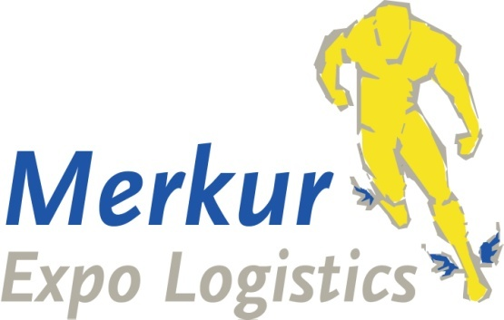


Delivery & Logistic Services
Merkur Expo Logistics GmbH has been appointed the official forwarding agent and clearance agent for all Kenes congresses We offers the following services: customs clearance, delivery to the booth, freight forwarding, manpower & trolleys for un‐loading/loading during build‐up and dismantling, storage of empty crates, transportation to and from the Exhibition Hall.
For security, insurance, and efficiency reasons, Merkur Expo Logistics
is the sole official agent to handle cargo inside the venue. Booth builders are prohibited from using trolleys during set‐up and dismantling periods.
Kindly note that Merkur the official agent is the exclusive agent for move in and move out of the venue.
Exhibitors and booth builders are free to deliver their goods or to pick their goods up from outside
the venue. Those who use their own facilities up to the venue are requested to coordinate their time schedule and unloading of their cargo into the venue with Merkur.

Contact Details:
Patricia Zintel, Project Manager
Tel.: + 49 (0) 6173 966 95 13
Fax.:+ 49 (0) 6173 966 95 29
Cell: + 49 (0) 170 2229525
E-Mail: patricia.zintel@merkur-expo.com

Pease note these important dates:

Due to Covid make sure to get update instruction closer to the congress
Buildup | August 11, 08:00 -15:30
Congress dates | August 11-15
Breakdown | August 15, 17:30 -20:30
SERVICE | DEADLINE
Door to door shipments | Please contact Merkur
Airfreight shipments | Please contact Merkur
Shipment via Frankfurt Advance warehouse ( No later than) | August 7
Exhibition goods - Direct deliveries to Congress venue | We highly recommend not to send goods directly to the venue

Services, Delivery Address & Shipping Instructions
1. Door to Door Shipment
We offer companies consolidated trucking services from starting point to venue as part of consolidated international shipments for the congress. This will assist in reducing costs and ensuring timely delivery.

2. Airfreight Shipments

Please contact Merkur for instructions.

IMPORTANT!!! Please do not send any airfreight shipment unless you receive very specific instructions for invoices, packing list, etc.

3. Shipment via Germany Advance Warehouse

Merkur Expo Logistics GmbH

Im Steinigen Graben 7

63571 Gelnhausen

Germany

Case marking:

Congress: IMC12, 2024

Exhibitor Name:
Hall Stand Nr:

Attention for all shipments we need a full pre-advice in advance. Please send your full pre-advice to Merkur.
Shipments with insufficient information’s or missing pre-advice might be delayed

4. Congress Venue

MECC Maastricht Forum 100, 6229 GV Maastricht

9. Heavy & Oversized Shipments
Heavy and oversized shipments apply to any single exhibit in excess of 1000 kg and 5 CBM that requires the use of a forklift mobile crane for installation.

Exhibitors with heavy and oversized exhibits must inform us at least seven days prior to delivery. A detailed layout should also be provided to better assist our onsite operations.

10. Payment terms

Terms of Payment

1. Invoices will be sent by e-mail only.

2. The invoicing is per shipment.

3. Full payment of the incoming handling charges must be received prior the delivery to the booth.

4. The outgoing handling charges are payable immediately after receipt of our invoice.

5. Payment can be made, by credit card (VISA and MASTERCARD) or by wire transfer. Personal or foreign cheques are not acceptable.

6. Vat will be added

7. 1,5% interest per month will be charged on overdue payments

please complete and sign the attached material handling form/payment confirmation and return it to our attention.
Please note that your signature will be used as payment guarantee based on the general tariff. Any services not outlined in the attached tariff will be quoted on an individual basis.

Please notify “Merkur” immediately about any requirements relating to invoices.
Please note that all payments are in €.

11.Terms and conditions
All orders are accepted exclusively on the basis of the local & German forwarders terms and conditions (ADSp).

We wish you a successful experience!
MERKUR EXPO LOGISTICS

